**Docker Compose**

Docker Compose is a tool for defining and running multi-container applications. It is the key to unlocking a streamlined and efficient development and deployment experience.

Compose simplifies the control of your entire application stack, making it easy to manage services, networks, and volumes in a single, comprehensible YAML configuration file. Then, with a single command, you create and start all the services from your configuration file.

Compose works in all environments; production, staging, development, testing, as well as CI workflows. It also has commands for managing the whole lifecycle of your application:

* Start, stop, and rebuild services
* View the status of running services
* Stream the log output of running services
* Run a one-off command on a service

Why Use Compose?

Using Docker Compose offers several benefits that streamline the development, deployment, and management of containerized applications:

* Simplified control: Docker Compose allows you to define and manage multi-container applications in a single YAML file. This simplifies the complex task of orchestrating and coordinating various services, making it easier to manage and replicate your application environment.
* Efficient collaboration: Docker Compose configuration files are easy to share, facilitating collaboration among developers, operations teams, and other stakeholders. This collaborative approach leads to smoother workflows, faster issue resolution, and increased overall efficiency.
* Rapid application development: Compose caches the configuration used to create a container. When you restart a service that has not changed, Compose re-uses the existing containers. Re-using containers means that you can make changes to your environment very quickly.
* Portability across environments: Compose supports variables in the Compose file. You can use these variables to customize your composition for different environments, or different users.
* Extensive community and support: Docker Compose benefits from a vibrant and active community, which means abundant resources, tutorials, and support. This community-driven ecosystem contributes to the continuous improvement of Docker Compose and helps users troubleshoot issues effectively.

Check Docker compose installed or not

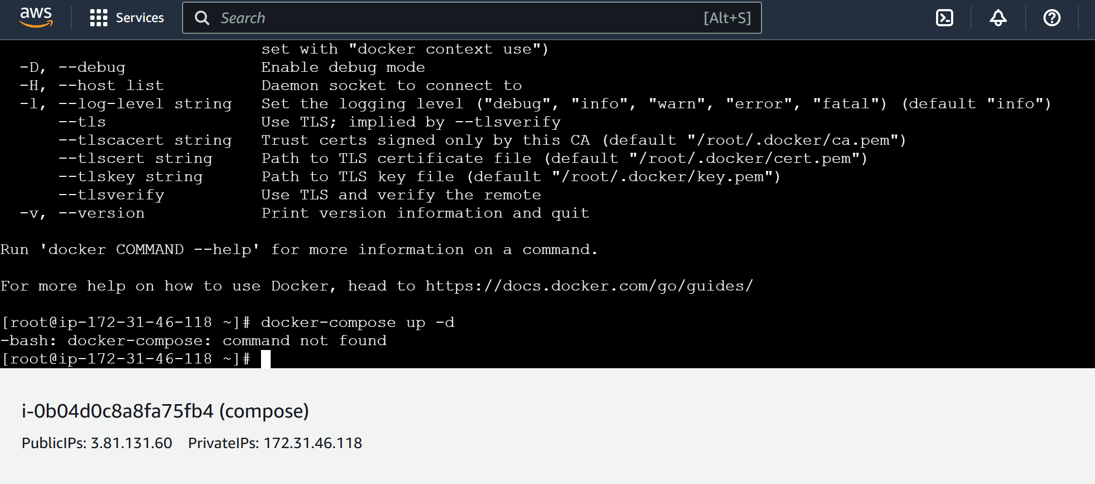

Docker compose installation

* curl -SL https://github.com/docker/compose/releases/download/v2.30.3/docker-compose-linux-x86_64 -o /usr/local/bin/docker-compose
* you need to give the permissions using chmod +x /usr/local/bin/docker-compose

Creating Docker Compose file

Vi docker-compose.yaml or yml

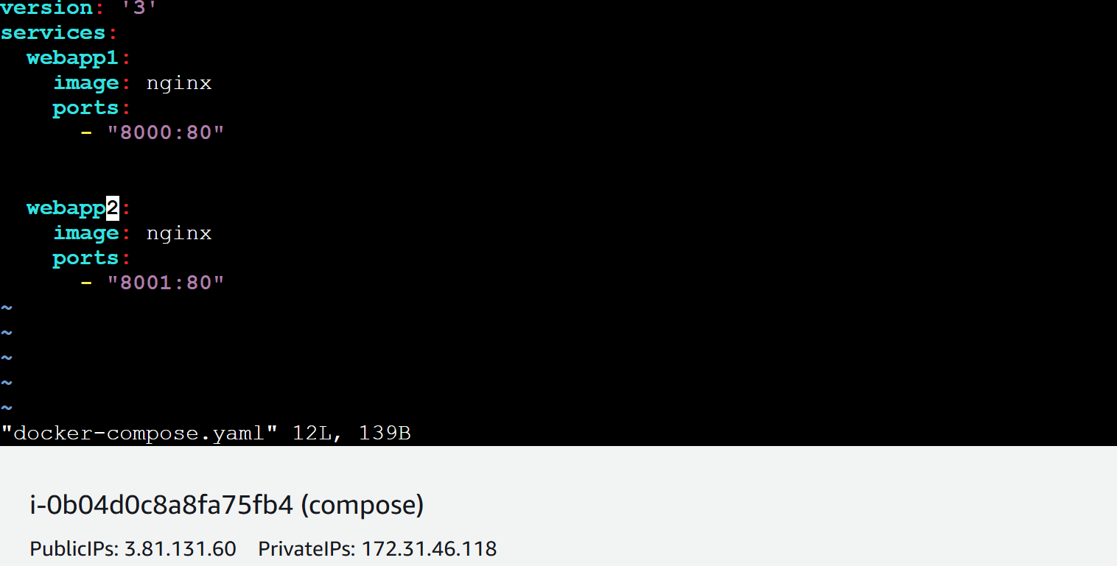

Then you have execute the file using this command

Docker-compose up -d

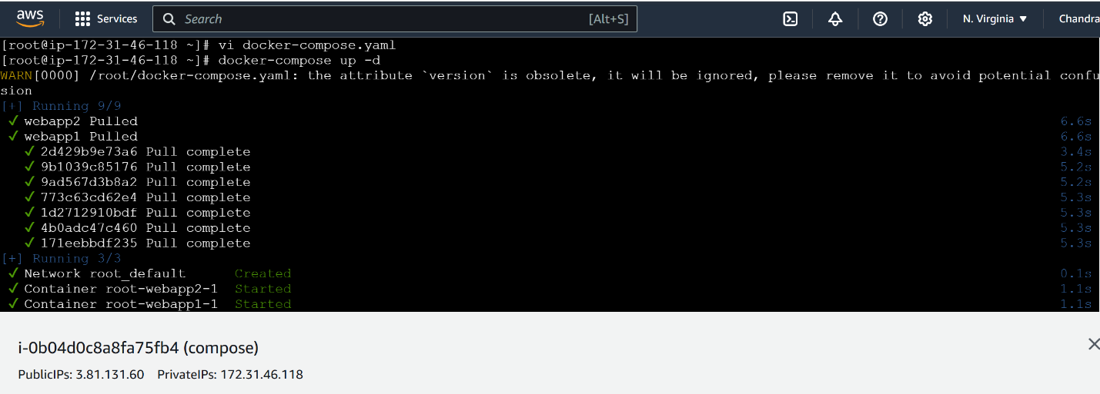

Output:

Go to browser copy ip address of instance and port number

Eg: Webapp1



Webapp2:

